PROOF OF TEST
EXECUTION OF MYE -12

NOTE: whenever an employee clicks on the Time-Sheet tracker link, then the self details page is displayed

Validation:
This test to validates the look and feel of the self-details page
Expected Result: look and feel of the self details should be able to displayed successfully
Screen Shot:
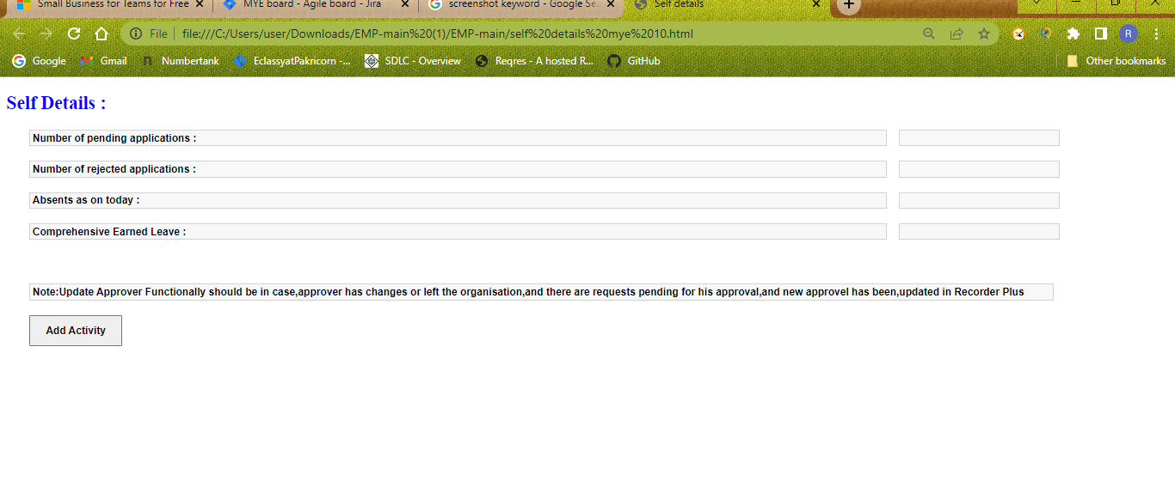

Validation - this test to validate whether a user should see number of pending application
Expected Result: pending applications counts should displayed successfully
Screen Shot:

Validation :
This test to validates whether a user should see the number of rejected applications

Expected Result: rejected application count should displayed successfully

Screen Shot:

Validation: This test to validate whether the user should see absent as on today
Expected Result: user should see absent as on today's count is displayed successfully

Screen Shot

Validation: this test to validate whether a user should see comprehensive earned leave

Expected Result: user should see comprehensive Earned leave count is displayed successfully

Screen Shot:

Validation: this test to verify ADD Activity button is displayed in self details page

Expected Result: User should be see ADD Activity button is displayed successfully

Screen Shot:

Validation: this test to click on Add Activity button and verify its is navigated to Pop up window

Expected Result: click on Add Activity button should displayed successfully

Screen Shot:

